***Carver Elementary School***

**http://carveres.wcpss.net**

Parent/Student Handbook Information

2014-2015

## Carver Elementary: “Home of the Cubs”

## School Mascot:

## Cub

**School Colors:**

Red and Yellow

**School Motto:**

“Creating Caring, Capable Citizens”

**MISSION STATEMENT:**

Carver Elementary School ensures that all students will succeed by building a learning community that is cooperative and supportive of the unique needs of each student through the use of research based strategies.

**VISION STATEMENT:**

Carver Elementary is a safe, nurturing, and trusting environment that inspires curiosity and creativity, while developing character, and leadership. Diversity and individuality are fostered along with effective work habits and problem solving skills in order to build successful lifelong learners.

**VALUE STATEMENT:**

We believe all students can learn and we are committed to:

* developing and fostering positive relationships between students, staff, parents, and community.
* establishing effective communication and collaboration among staff in order to develop and foster student success.
* embracing diversity and developing students of strong moral character.
* delivering a curriculum aligned to county, state, and national standards across all grade levels.
* using data to inform decisions and to provide differentiated instruction for students below and above grade level standards.

# A Word From Our Principal

**Dear Parents,**

**Parents are a child’s first, and most important, teachers. We, at Carver Elementary, value parent, family, and community support. We want your support and involvement.**

**At Carver, our goal is that each of our students experience success. As a school, we will offer our children the support, care, confidence, discipline, and classroom instruction necessary to foster success. Whether your child is returning to Carver, or is just joining our school for the first time, we welcome you to the Carver family and invite you to work with us. Together, schools and families can help children succeed.**

**Research shows that parent and family involvement has a great impact on student success. Parents are important partners in their child’s education. Your child has everything to gain from you being a close working partner with us at school. Let’s work together to make this the best year possible for your child! Home and school working together makes for a winning team!**

**We join with you in discovering what is best for your child.**

**Best wishes for a successful school year,**

**Katherine Faison, Principal**

**Greetings from the Carver School PTA**

**Welcome to all of our parents, teachers, and staff. We are very excited to be able to serve our school community this year. During this 2014-2015 school year, it is our goal to give everyone interested an opportunity to serve our students and school. We welcome and encourage all parents and teachers to provide the PTA with fresh, new innovative ideas to help make this school year one of our best ever.**

**We want all of our parent and teacher volunteers to know that you are the ones that make our school PTA successful. We hope that the PTA will become a tradition in your family and that you and your children will have a rewarding and wonderful school year at Carver. If you have any PTA questions please do not hesitate to get in touch with us. Again, welcome to our Carver family!**

**Thanks in advance for your support,**

**PTA Board**

**President: Daniel Honeycutt**

**Vice Presidents: Billy Cuthrell, Monte Jefferson & Shannon White**

**Secretary: Lucille Anderson**

**Treasurer: Ann Marie Sykes**

# Carver Student Pledge

I promise as a Carver Cub to:

Practice safety, be responsible at all times, use intelligent choices, demonstrate self-control, earn and give respect to teachers, staff, and peers.



Carver Cubs Growl!

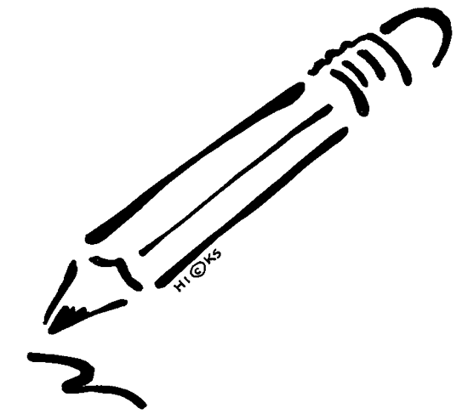Important Dates to Remember

**Reminder:**

**STUDENTS MAY ENTER THE BUILDING BEGINNING AT 8:45 AM. THE TARDY BELL WILL RING AT 9:15 AM. PLEASE DO NOT SEND STUDENTS INTO THE BUILDING PROR TO 8:45.**

First/Last Days of School Other Important Dates:

First Day: July 28, 2014 Meet the Teacher/Open House: July 24, 2014 (4:00-7:00)

Pictures:

Last Day: May 29, 2015 Curriculum Night: August 14, 2014,

5:45-Pizza served to families

7:00 -Curriculum Night Begins

**EARLY RELEASE FRIDAYS (LISTED BELOW) SCHOOL DISMISSES AT 1:15 PM.**

## Student Holidays Carver Early Release Days

# Labor Day: September 1, 2014 September 5, 2014

# Track-Out: September 29- Oct.10, 2014 October 17, 2014

# Veteran’s Day: November 11, 2014 November 7, 2014

Thanksgiving Break: November 26-28, 2014 February 13, 2015

Track-Out: Dec. 22, 2014 - Jan. 5, 2015 March 6, 2015

MLK, Jr. Day: January 19, 2015 April 17, 2015

President’s Day: February 16, 2015

Track-Out: March 9 - 20, 2015

Easter April 3, 2015

Memorial Day May 25, 2015

**Carver Parent-Teacher Dates (4:00 – 7:00 PM):** **Carver School Picture Days**

Fall Conference Night: September 18, 2014 Fall: *To be announced

Winter Conference Night: February 19, 2015 Spring: *To be announced

#### Interim Reports Quarter/End Date Report Cards go Home:

Home to Parents

#### **1st Quarter:** Aug. 27 **1st Quarter:** Sept. 26 **1st Quarter:** Oct. 15

**2nd Quarter:** Nov. 12 **2nd Quarter**: Dec. 19 **2nd Quarter:** Jan. 7

**3rd Quarter:** Feb. 4 **3rd Quarter:** March 6 **3rd Quarter:** March 25

**4th Quarter:** Apr. 22 **4th Quarter:** May 29  **4th Quarter:** May 29

**Awards Ceremonies (DATES ARE TENTATIVE):**

1st Quarter: October 24, 2014

2nd Quarter: January 9, 2015

3rd Quarter: March 27, 2015

4th Quarter: May 26, 2015: Kindergarten, First Grade & Fourth

May 27, 2015: Second & Third

May 29, 2015: Fifth Grade

# PTA Meetings (Times will be announced by phone messenger)

July 24 Open House: 4:00-7:00pm

August 14 PTA, Curriculum Night for parents/students

November 6 PTA Meeting, Math Family Night, activities at each grade level

December 4 PTA Meeting, Winter student program and Art Show

March 5 PTA Literacy Family Night, activities at each grade level

# May 14 PTA Meeting/Performance

**Fall Book Fair:** **Spring Book Fair:**

*To be announced* **\***To be announced*

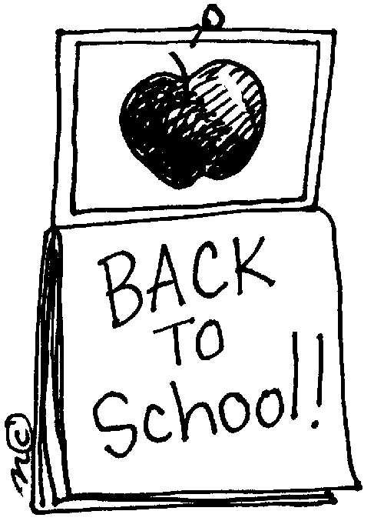

**The A, B, C’s of Carver Elementary**

**A is for . . .**

**Accidents:** Parents will be notified of accidents needing medical or immediate attention. Parents must be sure that the school always has a **current emergency phone number** on file.

**Accountability Agreement:** The Wake County Public School System has adopted proficiency standards for promotion in Grades K-8. Carver Elementary believes that students, parents, and staff must share responsibility for reaching these benchmark levels. The pledge to meet these standards is agreed upon by committing to the Accountability Agreement.

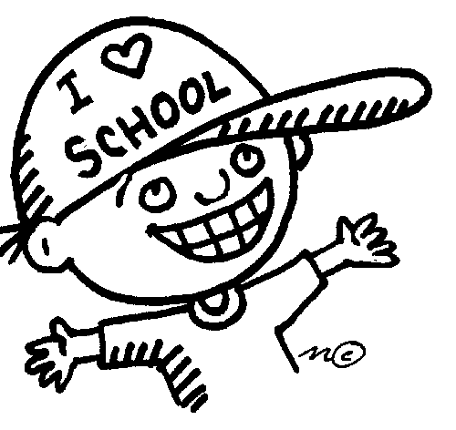**Arrival Time: The official school day begins at 9:15 AM.** **Our building opens for students at 8:45 and adult supervision begins at this time. No student should arrive prior to 8:45.** Students may report to their classrooms between 8:45 and 9:15. Teachers and assistants are on duty during this time to help supervise students. **When arriving by car, parents should unload children in the carpool area at the front of the school where staff is on duty.** **Under no circumstances should parents unload carpool students at the back of the building.** This is for the safety of all children. Thank you for your cooperation.

**Attendance:** Students are expected to attend school regularly. However, there are circumstances that require a student to be absent from school which are considered approved absences. These circumstances include:

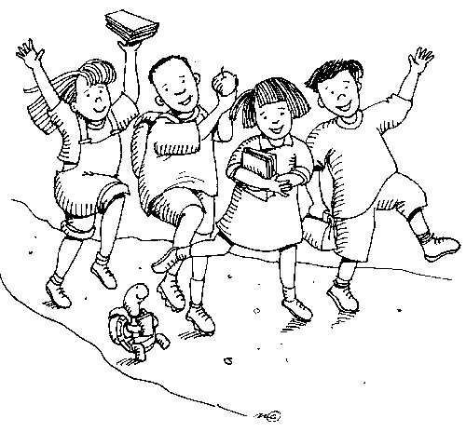

* Illness or injury
* Quarantine
* Death in the immediate family
* Medical or dental appointments
* Court or administrative proceedings
* Religious observances
* Educational opportunities

(Unless school sponsored require prior approval)

* Educational leave (requires prior approval)
* Other reasons excused by the principal

(requires prior approval)

Upon returning to school, **students should present a written excuse within two school days** from the parent/guardian stating the reason for the absence. **If a written excuse is not received within two days the absence will be considered unlawful/unexcused**. After six (6) unlawful/unexcused absences, a report is made to the counselor or school social worker. After ten (10) unlawful/unexcused absences, legal consequences may be necessary. **Students may make up missed work in the same amount of days missed. For example, should a student miss 3 days of school, they will have 3 days to make up any missed work.**

**To be considered in attendance for the school day, students must be present for at least three hours and fifteen minutes of instruction. (Students must remain in school until 12:30)**

**Attendance Areas and Proof of Residence:** In order for a student to attend Carver Elementary School, parents/guardians must reside in the Carver Elementary attendance area. Board Policy requires that parents present proof of residence. If you move outside the attendance area, Board Policy requires that parents request special permission for their child to remain in the school. It is the parents’ responsibility to notify the school of any changes in residence. Below is a list of possible documents that would serve as proofs of residence in parent or legal guardian name:

* Current utility bills (electric bills are accepted)
* A recently signed lease or purchase agreement

## Award Celebrations: Each quarter we celebrate to recognize student accomplishments. These dates have been set and can be found on page 4 of this handbook. Information regarding specific times will be sent home prior to each quarter’s ceremonies.



**Address Change/Telephone Number Change: Please notify the office and your child’s teacher immediately if you move or change your phone number during the year.** This information must be kept current.

**B is for . . .**

**Book Fair:** Our PTA sponsors an annual Book Fair each year. This is a great opportunity to buy books for your child and to help raise funds for the library. Our fall Book Fair dates have been set, see above dates.

**Books:** Students must take care of textbooks and library books. When books are lost or damaged, they must be paid for. Students and parents are held responsible for all books assigned or checked out to them.

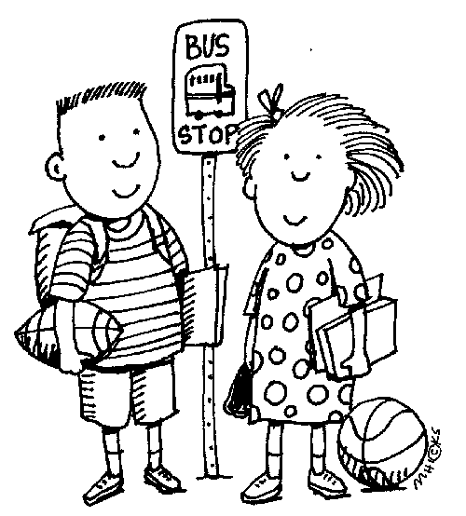

**Bus Transportation:** School bus transportation is a privilege that may be withdrawn for inappropriate behavior. A student is to ride the bus to which he/she is assigned. Students will be allowed off the bus only at school and at their designated stop on the route. Students riding the bus must comply with the requests of the driver. **Students should be at the bus stop 10 minutes before the bus is scheduled to arrive.**

**C is for . . .**

**Cafeteria Program:** The mission of our Child Nutrition Program is to serve nutritious breakfasts and lunches as well as a la carte items. The program is committed to removing foods that are high in fat and/or sugar from the choices available to elementary students. Changes being seen include new ice cream products, baked packaged snacks, reduced fat items, and 100% juices. Juice drinks and highly sweetened snack items have disappeared. There are many choices, but all meet the Winner’s Circle criteria. Students may pay for their breakfast or lunch on a daily basis or make weekly or monthly prepayments. Prepayment may be made in cash or by check to Carver School Cafeteria or on-line at mylunchmoney.com. Once a student has prepaid, the amounts of the meals purchased are subtracted from the child’s account.

* **Breakfast:** The cafeteria is open for breakfast each morning from 8:45-9:10. Students participating in the daily breakfast program should report directly to the cafeteria upon arrival at school. Students must arrive in the cafeteria by 9:10 in order to participate in the breakfast program (unless they arrive on a late bus). All students are expected to be in their classrooms by 9:15.
* **Lunch:** Students may buy lunch at school or bring it from home. If they bring lunch, they may buy milk or juice. We ask that no bottled drinks be sent to school.If a child forgets his/her lunch money, he/she will be given a vegetable plate. A fund for lending money is not available.
* **Lunch and Breakfast Numbers:** When students enroll at Carver, they are given lunch/breakfast numbers. This number will be used to identify students, their lunch status, and whether they have money in their account. Students keep the same lunch/breakfast number as long as they remain at Carver. It is mandatory that students know this number. Please assist your child in learning this number.
* **Breakfast and lunch prices** for elementary students are as follows for the 2014-2015 school year:

Student Breakfast Full Price $ 1.00 Reduced Price $ .30

Student Lunch Full Price $ 2.00 Reduced Price $ .40

Individual Items:

Milk $ .50 Ice Cream $ .75Juice $ .50 and $.75

Cookies $ .25 Smoothies $ .75

* **Free/Reduced Lunch Applications:** Parents can request an application to apply for free or reduced prices. Applications are submitted to Food Services where they determine if parents qualify based on income. Once applications have been submitted, it is mandatory that parents complete a new form if their income changes during the school year. **Parents will be required to pay for their child’s breakfast and/or lunch until the status of the application has been determined. Families are required to complete a new application each school year.**
* **Purchasing Extra Items:** During lunch we sell extra items for students to purchase. Students cannot purchase these items unless they have brought their lunch from home or have bought lunch from the cafeteria. These items are not intended to take the place of a healthy lunch. We do ask that students purchase no more than two extra items. If you wish for your child to have snacks at other times during the day, please send them to school with your child.

**Car Riders:** **Students who ride a car to school should be assigned a carpool number through the office. Student’s first and last names should be written on the tag clearly. Students should be dropped off and picked up at designated, supervised spots only.** Drivers should drive slowly and use caution when moving through the parking lot. **Please do not pass other vehicles, as it poses a danger to students.** Students will be called by name during dismissal and will be dismissed from a central location.

**Changes to a Child’s Transportation:** **If a child goes home by the bus or carpool and a change needs to be made, the parent/guardian must send a written note to school or call the school with the change.** If you call the school to request a change in the way that your child will go home, **it is extremely important that you call before 2:30 PM in order to allow the office staff time to notify the teacher and child.**

**Sending a verbal message by the child cannot be accepted.** Too often, children may forget the change or get confused about the change which may result in the child leaving school in the wrong way. This creates a frightening situation for everyone! **If the school is not contacted by the parent/guardian through written note or by phone, the child will be sent home by his/her regular form of transportation.**

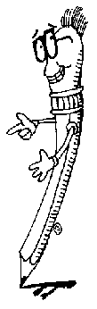**Check-In/Check-Out: Students arriving at school after the 9:15 bell must sign in at the office and will be considered tardy.** If students arrive late, the parent/guardian should come into the building with their child to sign them in or send a note in with their child explaining why the child is arriving late. Students arriving at school after 9:15 will be given a pass in the office to admit them to class.

**Because instruction begins at 9:15, parents should make every effort to get their child to school regularly on time. Parents/guardians should not pick their child up before 3:45 PM except in an emergency or if the child has a doctor/dental appointment.** If at all possible, please plan for doctor or other appointments after school hours and on school holidays. If a child needs to be dismissed early, he/she should bring a note to the teacher stating the time and reason.

All students must be checked out of school through the office. When parents/guardians must pick up their child early, they sign the child out in the office and allow the office staff to call the classroom; please do not go directly to the classroom. Records will be kept on early dismissals and late arrivals. Please work with us to protect instructional time.

**There will be no check outs after 3:15pm unless there is an *emergency,* as the carpool and bus lines are getting in place for dismissal.**

**Conferences:** Parent conferences are considered an essential part of a child’s education at Carver.Open communication between home and school foster success. Parents are encouraged to talk with teachers about their child’s progress. We hope that you will feel free to contact us at any time that you have questions or concerns. Conferences may be arranged by a note to the teacher or by calling the school (365-2680) to leave a message for your child’s teacher. Times may be arranged to conference with your child’s teacher after school or during his/her planning time. Parent-teacher conference evenings scheduled for 2014-2015 are:

Fall Conference September 18, 2014 4:00-7:00 PM

Winter Conference February 19, 2015 4:00-7:00 PM

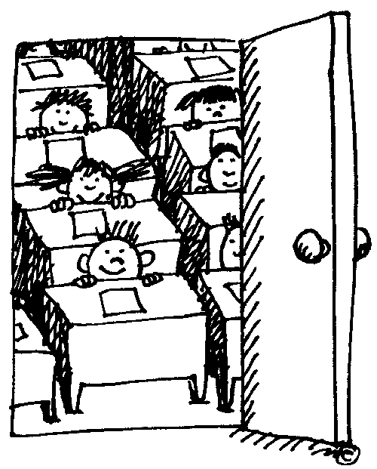

**D is for . . .**

**Daily Schedule: It is extremely important for students to arrive on time and stay until dismissal.** If a child consistently misses instruction, this will definitely influence the child’s academic performance. **If parents are going to change a child’s regular form of transportation, we ask that they send a note or call the school by 2:30 PM.**  Dismissal is an extremely hectic time. If a parent calls by 2:30 PM, this allows the office staff time to contact the child and the child’s teacher.

8:45 AM Adult supervision begins (No student should arrive prior to 8:45)

8:45-9:15 AM Homeroom Period (Students report to homerooms.)

8:45-9:10 AM Breakfast (Students must arrive in the cafeteria before 9:05 in order to participate in the breakfast program, unless they arrive on a late bus). Children will receive breakfast if their bus is late to campus.

9:05 AM Morning Announcements

9:15 AM Tardy bell rings. Instructional day begins.

3:45 PM Dismissal: Bell Rings

3:50 PM: Carpool & bus dismissal begins

**Damaged or Lost Materials:** If students lose, destroy, and/or damage a book, musical instrument, etc., while it is in their possession, it is the responsibility of the parent/guardian to reimburse the damages. This includes theft. Please note: Once payment has been made for a lost textbook or library book, payment will not be refunded. As a result, if the student locates the book after payment has been made, then the book will belong to the student.

**Discipline:** Students are expected to follow the discipline rules in their classroom and school-wide. We cannot and will not allow a student to steal precious instructional time from his/her classmates or to prevent others from having opportunities for learning. **Please review the section on discipline included in this handbook. Also, please review Wake County’s Discipline Policy included in the WCPSS Student/Parent Handbook provided by the county to each student.**

**Delays, Early Dismissals, or Closings due to Weather Conditions: Please inform us of the method of transportation you plan for your child in the event school is dismissed early due to inclement weather (ice, snow, flooding, early release, etc.) or any other unforeseen incident.** 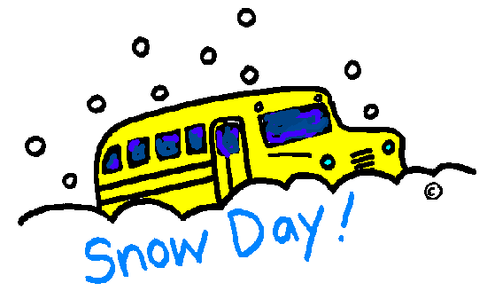The first notification of early school dismissal, delayed opening, or school closing is made to the local television and radio stations. If the weather appears threatening, please turn to a local station for information (TV channel 5 and Radio station 101.5 are recommended).

**Parents are encouraged to listen to the news media to learn of delays, early dismissals, or closings rather than calling the school for this information.** When calls are made to the school, it ties up our incoming lines to the extent that calls cannot be received or placed at the school. **Parents of students enrolled in day care centers should check with the center to learn if the center will pick up students when school is dismissed early**.

**Departure Time:** 3:45 - 4:15 PM Car pool and bus departures

CAR RIDERS PLEASE NOTE: All car riders will be dismissed in the afternoon at the gym area only. Car riders will not be dismissed through

the front (office area), side or rear exits of the building. Parents are asked

to stay in their vehicles and proceed through the line to pick up their children.

Please do not park and walk up to get students. These procedures are designed

for the safety and well being of your children.

E is for . . .

Early Release Days: On Early Release Days, students are dismissed at 1:15 PM. This includes buses and carpool. We will serve lunch before students are dismissed. On Early Release Days, staff members are involved in workshops and other required planning activities. Because staff members are involved in required activities and unavailable to supervise children, it is important that parents plan to pick up carpool students between 1:15-1:45 on Early Release Days.

Educational Leave for Students: By Board Policy, parents must make requests for Educational Leave to the principal in writing prior to a student’s absence from school. The request can be in the form of a letter or parents can pick up a form from the office. This request should be made at least a week in advance in order to allow time to notify teachers of the upcoming absence. When educational leave is approved, students are responsible for making up all work upon their return to school. Teachers cannot be expected to compile assignments prior to the absence. Before parents make a request for educational leave, they are strongly encouraged to consider the impact this will have on their child. Even though students will be allowed to make up missed assignments, there is nothing that can make up for missed instructional time. Students will be held accountable for learning the materials covered during the absence.

Emergency Drills: Emergency drills are scheduled periodically throughout the school year. Visitors, volunteers, and parents who are at school during a drill are asked to follow our evacuation procedures.

* Fire Drills: A fire drill is held each month that school is in session. Students are expected to follow the directions of their teacher during a fire drill. There is no running, talking, or disorderly conduct during a fire drill.
* Severe Weather Drills: Severe weather drills are held periodically. When the signal bell sounds, students and adults evacuate the classrooms and proceed to the designated areas. Teachers will practice drill instructions with students.
* Lockdown Drills: Lockdown drills are held periodically. Students are expected to follow

directions of their teacher during a lockdown drill. Teachers will practice drill instructions with students.

End-of Grade (EOG) Testing in Grades 3-5: Students in grades 3, 4, and 5 are required to take the North Carolina End-of-Grade Tests in Reading and Math. All third graders will take a beginning of the year test within the first 15 days of school. Students in grade 5 are required to take a North Carolina End-of-Grade Test in Science. (see page 19 for more information as well)

These tests are extremely important to your child and our school. The results become a permanent part of your child’s school records and are used to determine if a child meets promotion standards. It has been shown that involved parents can improve test scores! Parents can make the difference by communicating with his/her child’s teacher and working with their child at home. It is extremely important for parents to help their child with homework, to read to their child or let their child read to them, to reinforce math facts, and to make sure their child comes to school on time and prepared daily. Staff members will work with parents to help them find ways to help and support their child.

Enrollment/Withdrawal from School: Whether you are enrolling or withdrawing your child, it is extremely important to contact the school in which your child will be attending as soon as possible. The school where you are enrolling will contact the school from which you are withdrawing to request records. Before you leave, you should contact the office at the school where your child is currently enrolled to finalize your child’s records.

Expectations: We have high expectations for our students. Students are expected to come to school prepared to learn. We expect students to be on time, stay all day, complete all assignments, and give us their best each day. We expect our parents to support their child and the school, to assist their child with homework, and to encourage their child to put forth his/her best effort daily.

F is for . . .

Field Day: We schedule Field Day each spring. Students participate in activities for fun and fitness. We always need parent volunteers to assist with events. Field Day dates have been tentatively set for the spring. More information will be sent in the spring.

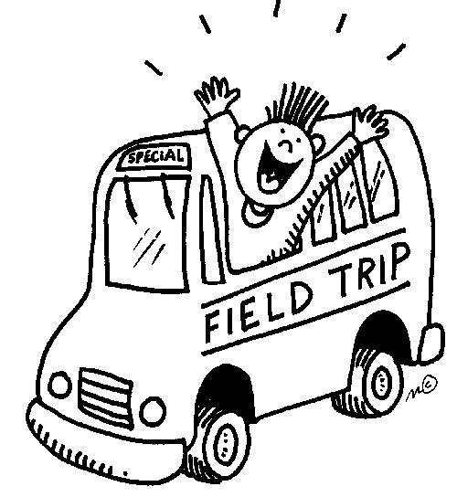Field Trips: Grade levels plan field trips during the year to enhance classroom instruction. All students going on field trips must have a field trip permission form signed by their parent or guardian. The signed permission form must be on file before the student is allowed to leave campus on a trip.

Fifth Grade End-of-Year Celebration: At the end of each year, Carver has traditionally planned a Fifth Grade Awards Celebration followed by a Fifth Grade Reception for students and their parents. This is an opportunity to celebrate the accomplishments of our fifth graders and salute them for a job well done! This special celebration has been funded and supported by our PTA. In order for it to be successful we also need the help of our parents! This celebration will be held on Friday, May 29, 2015.

Fundraising: PTA fundraisers help provide our school with supplies, materials, and resources. PTA fundraisers are sponsored annually. Your support is greatly appreciated!

Folders: Each week, information will be sent home in folders related to the child’s performance. This will include information related to the child’s academic performance and behavior. It will also include important information related to PTA, field trips, school-wide events and/or announcements. Parents are expected to review this information with their child, sign the folder, and return the signed folder the next school day. This is one extremely important way we communicate with parents on a regular and on-going basis.

G is for . . .

Guidance Counselor: Lauren Kaminskas is our guidance counselor. She provides support to students including individual and small group guidance, classroom guidance, and coordinating a variety of school-wide programs.

H is for . . .

Hall Passes: Students are not permitted in the halls during the instructional day without hall passes unless an adult accompanies them. This is to discourage students from traveling around the buildings without a teacher’s knowledge. This is for the safety of our children.

Homework: Students will have some homework each night. Homework planners have been purchased for children in grades 4-5. HOMEWORK SHOULD BE WRITTEN DOWN IN THE PLANNER FOR STUDENTS IN GRADES 4-5. PLEASE BE SURE TO CHECK YOUR CHILD’S PLANNER EACH EVENING AND REVIEW HOMEWORK ASSIGNMENTS. If your child says he/she finished homework at school, please take time to check over the completed work with your child. Every student in grades K-2 should read or be read to every night (including weekends). Third through fifth graders should also read each night. Your time is the best gift you can give to your children. Please help by supervising homework and reading time.

Homework Policy: In compliance with School Board Policy 5510, each school must develop a homework policy plan. You can find Carver’s homework policy on page 20-21 of this handbook and also on the school website.

I is for . . .

Immunizations: State law requires that every child have an adequate record of immunizations on file at school. Generally, if a student has been enrolled in another school and transfers to Carver, this information will be provided to us from the previous school. However, if this information is incomplete or not included in records sent, it is the responsibility of the parent/guardian to provide the school with this information. Failure to provide the school with your child’s immunization record within thirty (30) calendar days of his/her entry into school (first day of attendance) may result in suspension from school until the record is provided and/or immunizations are complete. State law requires the following minimum doses:

* 5 DTP, DtaP, or DT doses (If the 4th dose is on/after the 4th birthday, 5th dose is not required. DT requires medical exemption for pertussis.)
* 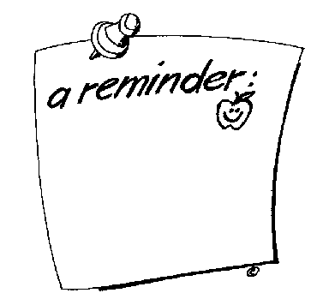Oral Polio-4 OPV/IPV doses (If 3rd dose is on/after 4th birthday, 4th dose is not required.)
* 1 Hib dose- (If a child is younger than 5, requirement is met if 1 dose is given on/after 15 months of age. Not required after age 5.) See complete law reference.
* 3 Hep B doses (Children born on/after July 1, 1994 are required to have 3 does.)
* 2 Measles doses (At least 30 days apart. 1st dose on/after 12 months of age.)
* 2 Mumps doses (On/after 12 months of age.)
* 1 Rubella dose (On/after 12 months of age.)
* 1 Varicella dose (On/after 12 months of age and before age 19 months, exception being individuals with a laboratory test indicating immunity or documented history of varicella disease.)



Information Sheets: At the beginning of the school year, all parents will be asked to complete student information sheets for their child. It is extremely important that these forms are completed and returned to school at that time. This allows us to update addresses, phone numbers, and other information that would be needed in the event of an emergency. Parents should also include those individuals to whom their child can be released. It is also mandatory that parents notify the school in the event that this information changes at any time during the school year.

Insurance: School insurance will be available to each student at the beginning of the school year. Parents will be provided with information about this voluntary program at the beginning of school. The premium and responsibility for completing the forms will be assumed by the students’ parent/guardian.

Internet Access: All students registered in the Wake County Public School System will automatically be given access to the Internet. Students are supervised in their use of the Internet at school. Students need access to the Internet for a variety of class activities. Parents have the option to deny their child’s access to the Internet. To exercise this option, please complete and return the Parental Request to Deny Access form (available on the district’s external web site or available by requesting a copy from the school office). We encourage all parents to allow students to access the Internet as a valuable instructional tool at school.

J is for . . .

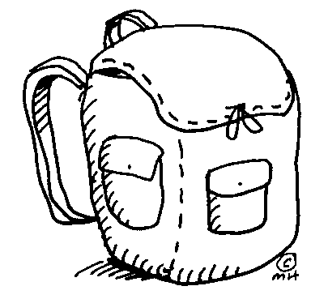

Jam-Packed: Your child’s day will be jam-packed with opportunities for learning. Please ask your child about his/her day at school, and encourage your child to discuss what was learned that day. Your child’s book bag will also be jam-packed with completed work, homework assignments, and notes/information from school. Please take time to check your child’s book bag each day.

K is for . . .

Kindergarten: The beginning of a great adventure! This is a most exciting time in a child’s early years and is the building block of your child’s education! Help us make it special for your child. Volunteer!

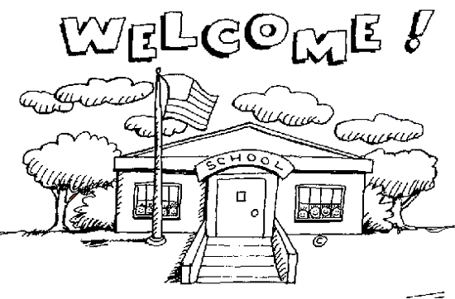

Kindergarten Enrollment: Certain information is required for enrolling a student into kindergarten. This information includes:

* **Age Requirement:** The State of North Carolina has made changes to the eligibility dates for children entering kindergarten. Beginning with the 2010-11 school year, students attending kindergarten must be 5 years of age on or before August 31, 2013.
* Birth Certificate: A certified birth certificate is required by N. C. state law for a student entering public school for the first time. The birth certificate must be provided at the time of enrollment. The “Mother’s Copy” of the birth certificate does not meet the requirement of state law. The birth date as indicated on the birth certificate shall be recorded on the student’s Permanent Health Record.
* 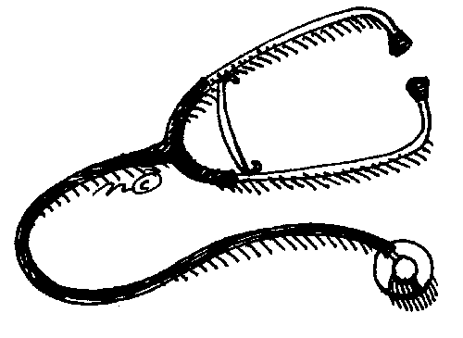Health Assessment: N.C. state law requires that kindergarten students have a health assessment completed by a physician. The assessment, which must include a medical history and physical examination with screening of vision and hearing, is to be completed within thirty (30) calendar days of the kindergarten student’s entry into school. If a health assessment is not provided to the school within that 30-day period, the student will be suspended from school until such time as the assessment form is complete. It is the parents’ responsibility to secure the health assessment from.
* Immunizations: N.C. state law requires that parents of kindergarten students provide a record of their child’s immunizations within thirty (30) days of their child’s entry into school. If a health assessment is not provided to the school within that 30-day period or the immunizations are not complete, the student will be suspended from school until the record is provided and/or shots are complete. It is the parents’ responsibility to secure the immunization record from the local health department or from a private health care provider.
* Proof of Address: In order for a student to enroll as a kindergartener at Carver Elementary, parents must present a proof of residence indicating that they reside in the Carver Elementary attendance area. Items accepted as proof of residence include: current electric bill, current gas bill, current water bill, or recent rental agreement or settlement statement.

L is for . . .



A Link to our school: The “Carver Cub Newsletter” is the monthly school newsletter intended to help keep parents informed of school-wide and grade level expectations, issues, activities, events, etc.

Lost and Found: Please be sure to mark your child’s coats, sweaters, hats, book bags, and other personal belongings with your child’s name so that items can be returned if misplaced. Articles that are found are taken to the office. Lost items can be claimed by proper identification.

M is for . . .

Medication: School officials may administer medication to students only if the following criteria are met:

* 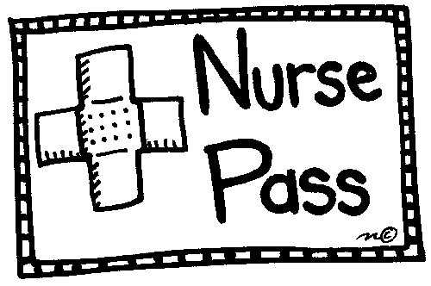The Parent Request and Physician Order for Medication Form must be completed and submitted to the school. The form can be obtained from the physician’s office or the school. Once the physician has completed these forms, parents can bring these by the school or have the physician fax the forms to school (school fax number is 365-2622).
* Medication must be sent to the school in the original bottle with the physician’s label. The parent/guardian should bring the medication into the office; please do not send medication in by the child.
* Medication forms must be completed each school year by the physician.
* School personnel cannot administer over-the-counter medication to students unless the doctor prescribes it and we have a Medication Form signed by the doctor on file at school.

**Medical concerns:** School staff should notify parents and arrange for children to go home when they have the following symptoms:

* Fever of 100 or higher (child should remain home until fever free for 24 hours)
* Nausea, vomiting, diarrhea (child should remain home until free of symptoms for 12 hours)
* Severe headache
* Red, watery eyes with yellow discharge
* Undiagnosed rash
* Inability to attend to learning activities
* Change in student’s usual medical status

CDC recommends that people with influenza-like illness **remain at home until at least 24 hours after** **they are free of fever (100° F 37.8° C ),** or signs of a fever without the use of fever-reducing medications.

Messages: Emergency messages may be left for students by calling the office at 365-2680. Office staff will see that the message is delivered. Messages may be left for school staff through the office. Class will not be interrupted for telephone messages.

**N is for . . .**

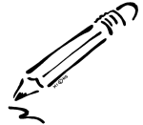

**Necessary Items:** Please make sure your child comes to school with all the necessary items for class each day. Pencils and paper are essential! Your child’s teacher will provide a list of items your child will need. Please replenish these items regularly!

**O is for . . .**

**Observing in Classrooms:** Parents are encouraged to visit classrooms; however, **parents/guardians are asked to notify the teacher a day in advance of their visit.** **Additionally, a confidentiality form must be signed.** It is important that we make the most of our instructional time. Visitors in the classroom can distract the children and, as a result, disrupt instruction. For the benefit of all children, it is important that the teacher is aware in advance and can prepare the children for visits. Please contact us if you have questions about visiting a classroom.

**Office:** Our school office is located to your right as you enter the main front doors. Mrs. Ramos, Mrs. Diener, or Ms. Taylor will be happy to assist in any way. **Parents and visitors must sign-in and sign-out at the office and wear a visitor’s badge when visiting the school.**

**On Time**: We want our students to develop the career habit of being on time. Arriving on time will not only help students have a successful school year but will also help in their future school and work experiences. Children may enter the building at 8:45 A.M. Arriving as early as 8:45 gives them plenty of time to prepare for their day. **REMEMBER, THE TARDY BELL WILL RING AT 9:15 AM.**

**P is for . . .**

**Perfect Attendance:** At the end of each quarter, students will be recognized for perfect attendance. If a child is late more than twice or misses any days from school, regardless of the reason, he/she will not be eligible for this recognition. We also recognize perfect attendance at the end of year. (A student with no more than 3 tardies will be recognized for end of the year perfect attendance.)

**Pictures:** School pictures will be taken twice each year and are available for purchase. In the fall, individual student pictures will be taken. A make-up/re-take day will be scheduled for fall pictures. In the spring, individual student pictures and class pictures are taken. There will be no make-up/re-take pictures for the spring. Yearbooks are available for purchase each year.

School picture days for the 2014-2015 school year are:

**Fall Pictures:** **Spring Pictures:**

*To be announced* *To be announced*

Pledge:

I promise as a Carver Cub to Practice safety, be responsible at all times, use intelligent choices, demonstrate self control, and earn and give respect to teachers, staff and peers. Carver Cubs growl!

**Positive Behavior Support:** Carver is a Positive Behavior Interventions and Supports (PBIS) school. The purpose of having a Positive Support Program (PBIS) is to impact the learning environment to support high student performance and to reduce behavior issues. We have developed school-wide expectations and procedures for all children. Children are rewarded for following the expectations set by the school. At Carver, we have Pride. Pride stands for “**Practice Safety, Be Responsible at All Times, Use Intelligent Choices, Demonstrate Self-Control, and Earn and Give Respect”.**

**Proficiency Standards:** Proficiency standards for promotion have been established for all students in kindergarten through fifth grade. Throughout the year, your child’s teacher will be able to share information with you concerning how your child is performing in relation to grade level expectations. Teachers will talk with parents about possible strategies to support their child’s continued growth. During the school year, we will conduct informational sessions related to promotion standards. Parents are strongly encouraged to attend. It is crucial that parents understand the expectations for each grade level. Please familiarize yourself with what your child must accomplish to be promoted to the next grade level. Parents should feel free to contact the school to arrange conferences with questions or concerns. Should you have questions, our school staff will be happy to talk with you.

**Progress Updates/Interim Reports:**  Progress updates (interim reports) and report cards will be issued to all students at the midpoint during each quarter. This will be a change from previous years. **A conference may be scheduled by parents at any time should you have questions about a progress report.**



**PTA:**  At Carver Elementary, we take great pride in our PTA. The PTA is one way in which parents and school staff can work together to accomplish common goals and make our school a better place. We are very proud of our active PTA and the support it provides our school. Please become actively involved. We will find a way to put your special interests or talents to work. We have a variety of committees and activities that need your help. Each classroom is also asked to have a PTA Room Representative. If you are interested in becoming involved, please contact your child’s teacher or call the office (365-2680). **PTA Membership dues for the 2014-2015 school year will be $6.00 for individual dues or $10.00 for family dues.** Dues can be turned in to any PTA officer, your child’s teacher, or directly to the school office.

**Q is for . . .**

**Questions:** If you have questions about your child’s progress or educational experiences, please feel free to talk with us. Our school staff members are happy to answer any questions you may have.

**R is for . . .**

**Refreshments:** If you would like to provide refreshments for your child’s class on his/her birthday, this needs to be planned in advance with the classroom teacher. We request that this be done during the class’s snack time or lunchtime, unless another time is specified by the teacher. Please check with your child’s teacher before sending any snacks for the class. Parents may be asked to provide refreshments for class parties, field trips, or other school events. Wake County Nutrition suggests that parents use **store bought** goods to make sure that students are safe in eating the snack brought in.

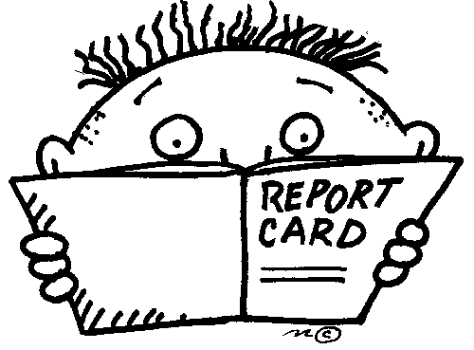**Report Cards:** Parents of all students in kindergarten – fifth grade will receive an interim report and a report card every nine-weeks. Interim reports will come at midway the grading period to indicate student progress. Report cards indicate children’s performance towards grade level standards. Please sign the report card envelope and return it to school the next day. Keep the report card. Please be sure to read any additional information enclosed with the report card. Don’t hesitate to contact your child’s teacher, should you have a question regarding his/her progress.

**S is for . . .**

**Students and Safety First! Our students are our first and most important priority!**

**T is for . . .**

**Team:** It takes every member of the school team – students, staff, and parents – to make a positive difference in a child’s education. We must all be sure we’re doing our part!

**Telephone:** Use of the telephone by students is limited to sickness, emergency calls, and school business only. Other matters should be taken care of at home. A note from the child’s teacher is required before the telephone may be used. Students will not be called from class to come to the telephone.

**U is for . . .**

**Utmost: Our students are of the utmost importance to the staff at Carver Elementary!** Every effort will be made to help them be successful. With your help, we will make a difference in your child’s life.

**V is for . . .**

**Valuables:** School staff tries to prevent losses, but they are not responsible for students’ personal property. Unnecessary money and/or valuables should not be brought to school. **Please be sure that personal belongings (especially coats/jackets) and clothing are labeled with your child’s name.**

**Visitors:** Anyone visiting our school must first check-in and check-out at the office and wear a visitor’s badge while on campus. Please remember to enter through the main entrance. Visitor parking is available in the front of the school and to the side of the gym.

**Volunteers:** We are always looking for school volunteers! Volunteers are needed in classrooms, office, special areas, and for special events. Parents, grandparents, and community members are all encouraged to volunteer. If you are interested in becoming a school volunteer please talk with your child’s teacher or call our school volunteer coordinators.

Your interest and involvement is needed and crucial to the success of our school. Our volunteer coordinator is Mrs. Ramos, our office receptionist (365-2680).

**Prior to beginning volunteer work, prospective volunteers must register online in the Media Center (this is required annually). Volunteers are also required to log all hours in the office.** **Please remember to register via the computer at the school.** Mrs. Ramos will be glad to assist you.

**W is for . . .**

**What to Leave at Home:** Anything not needed for class should be left at home. Toys should not be brought to school unless approved beforehand by the teacher. Matches, sharp objects, knives (including pocketknives), firearms (including toy guns), fireworks, tobacco, alcohol, and drugs violate local policy and/or state laws and will result in penalties including suspension.

**Withdrawals:** In case of a move that requires the withdrawal of your child from our school, please notify the school at least one day in advance by note or telephone. Textbooks and library books must be accounted for, and a transfer form must be completed.

**X is for . . .**



**X Marks the Spot:** And the spot your child should be in every day is his/her classroom! Please make sure your child is in attendance daily and on time with materials needed for a successful school day.

**Y is for . . .**

**Yearbook:** The school yearbook orders are taken each year. This book is an excellent way to preserve classroom memories forever.



**You:** Your support, involvement, and encouragement are essential for your child’s success at school. Be involved in your child’s education here at school!

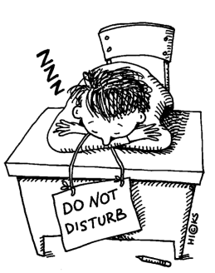**Z is for . . .**

**Z, z, z’s:** Make sure your child gets plenty of rest each night. Children need to

sleep at home, not in class! A well-rested child is more alert and ready to learn

than one who is tired or dozing during instructional time.

**Wake County Public School System**

**Promotion Standards**

**2014-2015**



Grades K-2:

#### Students will perform at Level 3 (proficient) or above in

the following areas:

WCPSS Mathematics Assessment

WCPSS Literacy Assessment

Grades 3-5:

Students will perform at Level 3 (proficient) or above in the following areas:



WCPSS Math and Reading Benchmarks

NC End-of-Grade Test of Reading Comprehension

NC End-of-Grade Test of Mathematics

NC End-of-Grade Test of Science (5th Grade Only)

**Rising third graders will receive a letter describing promotion standards set for reading. Please read this letter carefully to best understand these standards.**

Carver Elementary

Homework Policy

In compliance with School Board Policy 5510, each school in Wake County must develop a homework plan. This plan will be reviewed annually and updated as needed.

Homework assignments will be related to instruction and serve as an extension of activities that occurred during the school day. Because homework is an extension of the instructional day, it is important that all assignments are completed promptly. Planners have been purchased for children in grades 4-5. The planner is to be used to write down homework assignments. It allows a method for teachers to communicate with parents on a daily basis concerning daily homework assignments. Teachers will also send weekly folders as a method of communication with parents concerning the child’s performance. The weekly folder may contain information about homework assignments.

**If there are questions about your child’s homework or about whether their child is completing homework assignments regularly, parents should contact the school as soon as possible.** Don’t wait! If a child is not completing homework or does not understand the homework assigned, it will affect his/her performance and progress. Homework is an important area that the classroom teacher and the parent must work together as a team to insure the success of every child.

Homework can be assigned at all levels K-5.The purpose of homework will be the following:

* To enrich and extend school experiences through related homework activities
* To reinforce learning by providing practice and application
* To stimulate effort, independence, responsibility, and self-direction

Homework will be assigned for the following reasons:

* Drill, practice, application, extension, enrichment
* Continuation of unfinished class assignments
* Independent projects and research

The following time parameters have been established and outlined below. **Please note: homework (including reading, research, and other long term projects) will not be assigned during a student’s track out periods.**

* The average child in grades 3-5 will spend approximately 50 minutes per night on homework. The average child in grades K-2 will spend approximately 20 minutes per night on homework. In addition, nightly reading may be assigned to students at all grade levels. With kindergarten students, no homework may be assigned at the beginning of the year; however, homework will be assigned as students become more proficient and independent learners. The length of initial homework assignments in kindergarten will be based on the individual needs of the learners.
* Projects and research may be spread over a period of several nights or weeks.
* No required amount of homework will be given each night.

Because homework is designed to help students with a wide range of subjects and to reinforce many different skills, assignments should be varied. The types of homework can include, but are not limited to, the following:

* Continuation: Completing assignments started in class
* Reading: Using textbooks, library materials, leveled books, reading books, and reference works
* Writing: Creative writing projects, compositions, and summaries
* Experimentation: Working to uncover further findings of an experiment already initiated in class
* Research: Working on projects
* Practice: Practicing fundamental skills of a particular subject
* Observation: Purposefully seeking ideas and information through such activities as viewing television programs or plays or preparing evaluations of these
* Memorization: Committing to memory such material as poems, speeches, plays, words and their definitions, and mathematical formulas
* Exhibits: Collecting and preparing materials for others to view and examine
* Make up work: Completing essential or appropriate work missed during absence
* Interviews: Gathering information from authoritative sources through personal contacts

Homework assignments will vary according to the differences in students’ abilities and according to the grade level in which the students are assigned. Homework assignments will be reviewed daily. If your child does not have homework for several nights in a row, please contact the child’s teacher.

Homework is not assigned on PTA nights or school events.



Carver Elementary

School-Wide Discipline Program

MC900281692[1]**Positive Behavior Interventions and Supports**

Carver is a Positive Behavior Interventions and Supports **(PBIS)** School. Here are some of the guiding principles of this program:

* Positive Behavior Support Programs are a way to impact the learning environments in the schools in order to support high student performance and to reduce behavioral problems.
* Whole School PBIS is a systematic approach that establishes and reinforces clear behavioral expectations.
* It is a team-based system involving the entire school staff using a systems approach.
* The school staff must adopt a common approach to discipline that is proactive, instructional, and outcome-based.
* The data about the school is used to guide decision making.
* The school team looks at the entire school campus and the whole school day.
* The goal is to help educate all students, even students with challenging behaviors.
* There is an emphasis on continuous, data-based improvement, individualized to each school.
* PBIS is also an instructional approach that focuses on systematically teaching social behavior using effective instructional methodology.
* Systematically teaching and implementing behavioral interventions for the most difficult students is also a key component.

Carver uses the acronym “**PRIDE**” to show our five traits we are looking for in all school settings.

**PRIDE** stands for:

**Practice Safety**

**Responsibility Is Key**

**Intelligent Choices**

**Demonstrate Self Control**

**Earn and Give Respect**

For each area in our school there is a Pride Matrix that provides specific expectations of positive actions students may display for successful behavior. There is a matrix for the hallway, cafeteria, restroom, playground, and arrival/dismissal. Below is a sample matrix for the Hallway:

|  |  |
| --- | --- |
| **Practice Safety** | * I will walk facing forward * I will handle shoe issues at the appropriate time * I will move quickly and quietly during emergency drills |
| **Responsibility Is Key** | * I will walk in the 3rd square * I will walk on the appropriate side * I will use a pass when needed |
| **Intelligent Choices** | * I will walk directly to and from my destination * I will carry my belongings appropriately * I will stop and yield to others |
| **Demonstrate**  **Self-Control** | * I will look without touching displays * I will stay in my space and accept my place in line * I will keep my hands and feet to myself |
| **Earn and Give Respect** | * I will respect learning by walking quietly without touching objects on the wall * I will listen and follow directions of all adults |

Lessons for each of the designated areas are taught and reinforced at the beginning of the school year, when students track back in after each break, and whenever otherwise needed.

Individual students and classes are able to earn incentives. When a class is caught demonstrating **PRIDE**, the class earns a **PAW**. After the class accumulates a certain amount of **PAWS,** they earn a special class reward. There are several areas that a class can earn a **PAW**. Some examples include the cafeteria, specialist’s classes, and the hallway.

Individual students can also earn a positive reinforcement for demonstrating the **PRIDE** throughout the school.

When a student is caught demonstrating **PRIDE** he/she is given a special ticket.

**Pre-K through Second Grade:**

The student writes his/her name on the back of the ticket and it goes into a class drawing. Once a week a certain number of tickets are drawn from each class and those students can go to the Carver Cave store to choose a small prize.

**Third through Fifth Grade:**

These students work to accumulate their tickets and turn them in for a variety of prizes from our PRIDE Rewards Matrix. Some prizes include:

25 Tickets: Brag phone call home, teacher helper

50 Tickets: Computer time, lunch with your teacher, mechanical pencils

75 Tickets: Sit at your teacher’s desk for the day, specialist helper

100 Tickets: Office helper, Pre-K/Kindergarten helper, PRIDE Hall of Fame

125 Tickets: No homework pass, lunch with Principal or Assistant Principal

150 Tickets: Principal helper, lunch from McDonalds

Over the past three years Carver has continued to expand our PBIS program and incentives. The school has seen dramatic changes with students’ understanding of expectations and appropriate behavior throughout the school. We hope to continue to expand our PBIS program and incentives and need your help. Please ask your child what is expected of them in the specific areas of the school and review that with them daily. Reinforce the positive things your child does to help them to continue to make the right choice.



# ☹ Automatic Referral to the Office ☹

The following offenses will result in automatic referral to the office. Once the child is referred to the office for these offenses, the child may be suspended and/or a parent conference may be required.

1. Fighting
2. Serious physical harm to and/or physical assault on an employee or another student (Regardless of previous referrals to the office, students will be automatically suspended for serious physical harm to an employee or another student, and a referral will be made to the appropriate community agency.)
3. Weapons on the school grounds (Bringing weapons on the school grounds, including school buses and bus stops will result in an automatic referral to the office resulting in suspension and a referral to the appropriate community agency.)
4. Serious damage to property
5. Chronic stealing (more than 2 separate occasions after conferencing with parent and student).
6. Chronic behavior problems
7. Serious threats to staff members and/or other students
8. Leaving school grounds without permission
9. Pulling Fire Alarm

Pulling the fire alarm will result in automatic suspension. This is very serious and could create an extremely dangerous situation for students and teachers. Teachers are required to explain this to students during the first week of school.

Cafeteria Expectations

We recognize that children need time to socialize. We want to maintain a positive atmosphere at lunch which requires certain expectations to be enforced consistently. Our general expectations are listed below.

* Students should enter and exit the cafeteria quietly and remain silent in the lunch line.
* Students should use “inside voices” and talk only to those students seated at their table.
* Students should clean up after themselves. Items/trash should not be left on the table or floor.
* Students should not share food.
* Students should not leave their area without permission.

Weapons

Weapons including knives, razors, explosives, fireworks, guns, facsimiles of guns, and/or any other object that can reasonably be considered dangerous instruments are forbidden on any Wake County school campus. Any student having a dangerous weapon on campus will be reported to WCPSS Security and the local police. (Please refer to WCPSS Board Policy 6427)

Pagers, Laser Pointers, Radios, Games, Etc.

Pagers, laser pointers, radios, games, and other non-instructional items are not to be brought to school. These items are also not allowed on school buses. Students who violate this policy will be required to leave the items in the office until parents/guardians come to school to collect them.

***Cell phones-if a student has a cell phone in his/her book bag if must remain turned off turning the school day. If it is stolen or lost, the school is not responsible. If it rings or makes noises during the day, we will remind students the first time to turn off the phone. If we continue to have problems with the phone ringing or making noise, we will call parents/guardians to pick it up from school. Thanks for your attention to this.

Toys

Toys should be left at home unless they are brought to school with the permission of the teacher as a part of a class project or activity. Toys distract from instructional activities and our staff cannot be held accountable in the event that toys from home are lost or stolen. Staff members will collect “unauthorized” toys and keep them until parents/guardians come to school to collect them.

Sale or Trade of Items

Students are not to engage in the sale or trading of any items with other students (for example: selling/trading cards, games, music, candy, gum, pencils, clothing, or any other personal items). Selling/trading items is prohibited and could result in suspension. Confiscated items will be held in the office until parents/guardians come to school to collect them.

PLEASE NOTE:

All students are responsible for complying with and are expected to be familiar with the WCPSS Code of Student Conduct and school board policies governing student behavior and conduct.  All Code of Student Conduct policies are contained in the WCPSS Student/Parent Handbook, which is distributed to all students and parents at the beginning of each school year or upon enrollment in the WCPSS.  If there is a conflict between the rules expressed in this handbook/agenda/planner and the Code of Student Conduct policies, the WCPSS Code of Student Conduct policies shall take precedence.

Todas las políticas del Código de Conducta Estudiantil se encuentran en el manual de WCPSS de Estudiantes/Padres, el cual se distribuye a todos los padres y estudiantes al principio de cada año escolar o al matricularse en el WCPSS. Si hay un conflicto entre las reglas expresadas en este manual de Estudiantes/Padres y el manual/agenda/planificador de la escuela de su hijo(a) las reglas expresadas en este manual deben tomar prioridad.

*No printed word*

*Or spoken pleas*

*Can teach young hearts*

*What men should be,*

*Not all the books*

*On all the shelves*

*But what the teachers and parents are themselves.*

***-Anonymous***





**Student Dress Code**

The Wake County Board of Education has adopted a dress code for ALL Wake County Public Schools. Parents should read this dress code very carefully and make every effort to comply with the expectations. In the past, our parents and students have used good judgment in determining clothing. Because of this, we have had few problems in this area. In the event that a student dresses inappropriately, parents will be contacted and asked to bring the student a change of clothing before the student is allowed to return to class.

**School Policy 6410.1 - Student Dress Code**

Inappropriate Dress - Principals shall exercise appropriate discretion in implementing this policy, including making reasonable accommodations on the basis of student’s religious beliefs or medical conditions. Students are expected to adhere to standards of dress and appearance that are compatible with an effective learning environment. Presenting a bodily appearance or wearing clothing which is disruptive, provocative, revealing, profane, vulgar, offensive or obscene, or which endangers the health or safety of the students or others is prohibited. Examples of prohibited dress or appearance include, but are not limited to: exposed undergarments; sagging pants; excessively short or tight garments; bare midriff shirts; strapless shirts; attire with messages or illustrations that are lewd, indecent or vulgar or that advertise any product or service not permitted by law to minors; head covering of any kind; see-through clothing; attire that exposes cleavage; any adornment such as chains or spikes that reasonably could be perceived as or used as a weapon; and any symbols, styles or attire frequently associated with intimidation, violence or violent groups about which students at a particular school have been notified. Individual schools are free to specify additional examples of dress or appearance that are prohibited at that school under the terms of this policy.

If a student’s dress or appearance is such that it constitutes a threat to the health or safety of others, distracts the attention of other students or staff from their work, or otherwise violates this dress code, the principal or principal’s designee may require the student to change his or her dress or appearance. A second or repeated violation of this policy may result in disciplinary action.

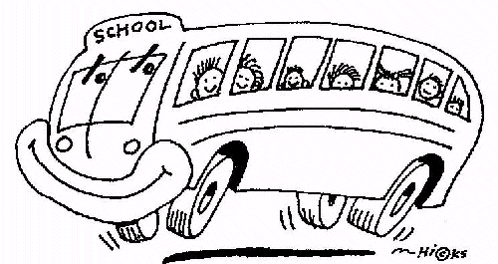

**Building a Quality Transportation System**

**Bus Rules and Regulations**

Bus transportation is a privilege extended to those students who live in the Carver attendance area and behave in a manner consistent with the rules and regulations of Carver Elementary, Wake County Public Schools, and Public Laws of North Carolina. The school bus is an extension of the school day and all rules and regulations apply. Failure to comply with these rules will result in the denial of transportation privileges and/or suspension and expulsion.

At Carver Elementary School, we have clearly defined rules and expectations that lead to a safe and positive environment for all buses. Teachers will review these rules, as well as, general safety throughout the year. However, during the first two (2) weeks, we will focus on bus safety. During this time, students will be made aware of the duties and responsibilities involved in being a good school bus passenger. We hope that our parents will also voice their concern to their child about conduct on the school bus.

Following is a list of rules, which we expect students to know and follow:

1. Passengers must be on time. The driver has a schedule to follow and cannot wait for tardy passengers.
2. A passenger must stay off the street or roadway while waiting for the bus. Students are expected to stand by the road, several feet from the pavement. They should wait until the bus comes to a full stop and then board the bus. If they must cross the street, they should walk quickly (not run) to the bus.
3. Take a seat as soon as possible once on the bus. Refrain from moving around while the bus is in motion. Remain seated until the bus reaches the unloading area.
4. Passengers should get permission to open the windows.
5. Keep hands, arms, and feet inside the bus at all times.
6. Objects should never be thrown about the bus or out of a window.
7. Passengers should never eat or drink while on the bus.
8. Aisles should be kept clear at all times.
9. Personal belongings should be kept in the passenger’s lap or placed under the seat.
10. Profanity, indecent language, alcohol, or tobacco products are strictly prohibited.
11. Passengers should maintain complete silence at all railroad crossings.
12. Passengers should not tamper with the emergency door.
13. Passengers should never deface the bus in any way.
14. Passengers should never tamper with the fire extinguisher or first aid supplies.
15. Passengers should not ride on the bus unless assigned by the principal or designee.
16. Passengers should not rush to get off the bus. Pushing or shoving will not be allowed. Passengers should remain in position until the bus has completely stopped.
17. Passengers should always get on and off at designated stops. This can only be changed with the knowledge and approval of the principal.
18. Observe classroom conduct while riding the bus.

Be courteous.

Respect the rights of others.

Cooperate with the driver in every way. A distraction could cause an accident.

Stay in your seat.

Talk softly.

Help keep the bus clean.

Keep hands and feet to yourself. (No kicking, hitting, or fighting)

**Discipline Procedure**

We will follow a sequence for bus discipline. The first two reports of misconduct will be handled through warnings and/or removing privileges. The office will issue a warning letter and/or make a phone call to parents. Any future referrals may result in suspension from the bus. If a child is suspended from the bus, it is the parent’s responsibility to transport the child to and from school. The exception will be fighting, drugs, alcohol, and/or weapons. These will result in automatic suspension/expulsion.

**Adults Boarding the School Bus**

**Adults are not allowed to enter a school bus without the permission of the** **Transportation Supervisor, the principal, or assistant principal.** N. C. State Law 14-132.2 Section B states: “Any person who shall enter a public school bus after being forbidden to do so by the authorized school bus driver in charge thereof, or the school principal to who the public school bus or school activity bus is assigned, shall be guilty of a misdemeanor punishable by a fine not to exceed one hundred dollars ($100.00), imprisonment for not more that 30 days or both.” If parents need to speak to the driver, please send a note to the driver including your phone number for the driver to call you. Please do not talk with the drivers at the bus stop. They must keep their schedule, and they block traffic when stopped.

###### Carpool Information

**Our major goal is to ensure the safety of our children!** We realize that this is also your concern as parents. During the past several years with the support of parents, we feel that we have developed efficient and effective methods for use with carpool. **Carpool drop-off/pick-up procedures will remain unchanged. Students will be dropped off in the morning and loaded for pick-up in the afternoon at the front of the school in the carpool loop.** We will work with you daily to make car pool work smoothly and safely.

Staff members will be on duty each morning and afternoon supervising children. We do need parents’ continued support in making our carpool process simple, fast, and, most importantly, safe. Please help us by following the procedures listed below:

* All children will be unloaded/loaded in designated areas only (morning and afternoon carpool will unload/load in front of the main building in the carpool loop.
* Children will be unloaded/loaded by supervising staff members. Please reinforce with your child to follow the supervising adults’ instructions. Safety is our first priority! We cannot risk the chance of a child running out in front of a car. Saving a few seconds of time is not worth a child’s life! We ask parents to wait patiently.
* Due to liability concerns staff members are not permitted to fasten or unfasten any seat belts or safety restraints.
* Children should not be released from other exits to load in the afternoon. All car riders will be released from the gym and walked outside by a staff member.
* If parents plan to pick up children prior to carpool dismissal, they must go by the office first. We cannot release children to parents who go to the classroom to pick up children without an office pass.
* Parents must send a note or call the school if their child will be going home by a different form of transportation.
* **Children may not be picked up after 3:15, except in the case of an emergency. At dismissal time, please do not come into the school to pick up your child. Because of the limited space, this will stop the flow of traffic and slow down the entire process for everyone. Please wait in the carpool line and we will load students as quickly and safely as possible.**
* Parents will be given a carpool tag with the child’s name on it, to display in their window. **THIS TAG SHOULD BE DISPLAYED THROUGHOUT THE YEAR.** We will have a corresponding list to identify children as they are picked up from school.
* Keep in mind that the first few weeks of school, the process may be slower as students and parents become familiar with the process. Please be patient!

We will continuously evaluate all areas of our school to make sure our environment is safe. We are extremely concerned for the safety of “our” children, and we must work together as a “school family” to provide the safest environment possible. By working together, we can make Carver even better!



*Children Learn What They Live*

If children live with criticism,

they learn to condemn.

If children live with hostility,

they learn to fight.

If children live in shame,

they learn to feel guilty.

If children live with tolerance,

they learn to be patient.

If children live with encouragement,

they learn confidence.

If children live with praise,

they learn to appreciate.

If children live with fairness,

they learn justice.

If children live with approval,

they learn to like themselves.

If children live with acceptance and friendship,

they learn to find love in the world!